Task 10

Name # Muhammad Ali

Sid # 9363

Design a given network which consists of 13 routers. Configure OSPF, EIGRP, RIPv2 &

Static Routing in specific areas as per assigned in lab session.

Each environment consists of three routers. While one router is a redistributed router.

The purpose of each routing protocol is to provide communication from its particular

environment to redistributed router. In this evironment, different routing protocols

will not communicate with each other. EIGRP and OSPF process IDs should be your student

IDs. Use the network addresses which have been assigned in lab session.

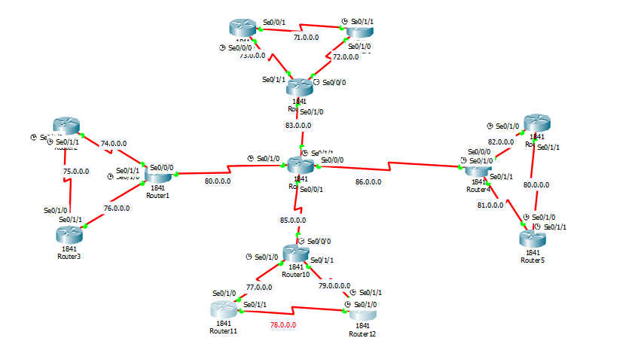

Static Routing



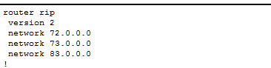 Router Ripv2

Border Router